**BMS COLLEGE OF ENGINEERING**

**(Autonomous College under VTU)**

**Bull Temple Road, Basavanagudi, Bangalore - 560019**



A project report on

***“AIR TICKET RESERVATION”***

Submitted in partial fulfillment of the requirements for the award of degree

**BACHELOR OF ENGINEERING**

**IN**

**INFORMATION SCIENCE AND ENGINEERING**

By

Sridhar M A (1BM12IS082)

Sunaina B (1BM12IS087)

**Under the guidance of**

Ms. Shubha Rao

Ms. Nalina

**Department of Information Science and Engineering**

**2014-2015**

|  |  |
| --- | --- |
|  | **BMS COLLEGE OF ENGINEERING**  **(Autonomous College under VTU)**  **Bull Temple Road, Basavanagudi,**  **Bangalore – 560019** |
| **Department of Information Science and Engineering** | |

**C E R T I F I C A T E**

This is to certify that the project entitled “***Air Ticket Reservation***” is a bona-fide work carried out by **Sridhar M A** (1BM12IS082)**, Sunaina B** (1BM12IS087)in partial fulfillment for the award of degree of Bachelor of Engineering in **Information Science and Engineering**  from **Visvesvaraya Technological University, Belgaum** during the year **2014-2015**. It is certified that all corrections/suggestions indicated for Internal Assessments have been incorporated in the report deposited in the departmental library. The project report has been approved as it satisfies the academic requirements in respect of project work prescribed for the Bachelor of Engineering Degree.

**Guide Name Dr. Gowrishankar Dr. K. Mallikharjuna Babu**

**Designation Professor and HOD Principal**

**Examiners**

**Name of the Examiner Signature of the Examiner**

1.

2.

Abstract

The Web Programming project done comprises of a website made in order to check the flight schedule and book air tickets online. After the registration and selection of flight based on availability, the user’s details are displayed and subsequently the tickets are booked and details are updated.

Index

1. Problem statement……………………………………………3
2. Abstract………………….……………………………………3
3. Introduction……….…………………………………………..3
4. Analysis………….………..…………………………………..4
5. Design………….……………...………………………………4
6. Implementation.……………………………………………….5
7. Snap shots……………………………………………………..5
8. Testing…..…………………………………………………….6
9. References…………………………………………………….9
10. Problem statement

Design and validate an Air Ticket Reservation System.

1. Abstract

The Web Programming project done comprises of a website made in order to check the flight schedule and book air tickets online. After the registration and selection of flight based on availability is done, the user’s details are displayed and subsequently the tickets are booked and details are updated.

1. Introduction

The Web Programming project comprises of a website made in order to book air tickets online. After viewing the flight schedules and selecting a particular flight, the user has to confirm the details displayed after which his tickets will be booked. The respective project contains both client side and server side functionalities playing their respective roles.

1. Analysis

The problem statement stated that the resulting product needs to be Air ticket Reservation. In order to implement this, the following components were taken into consideration:

1. In the Air ticket reservation system, there is one database with four tables. One for Registration-Login entry and validation.
2. There is one table for all the flight details and the other two include user-details about the flights and seats booked in a particular flight.
3. In order to make sure the flights booked by User A is not is not assigned to another user, each time a user logs into the website, their details are taken and a new session is started having updated session variables with the newly logged in user’s details.
4. Client side programming is used to fill in the form with flight details based on schedule and is passed to the XHTML components which in turn passes it to the server side.
5. Server side programming uses Session variables for login and flight details.
6. It then displays flight details along with name stored in session variables and modifies the flight-booked and name-flight details table.
7. Design

The design of the project is kept relatively simple for the programmer. Each aspect of the project is discussed below:

1. There is one distinct login page and another registration page if the user is trying it for the first time.
2. Once the user logs in, a page which asks the user whether he wants to book a Domestic flight or an International flight is displayed. On selecting one of these, a form page is displayed where the user has to fill in the details of his air travel which includes destination, departure time, date etc.
3. In order to view the flight schedules , he can do so in the above page where he is provided with that option
4. Once the user fills in the form, the flight based on his needs is displayed. On Selecting and submitting, his tickets will be booked. If no flights are present, then a pop-up will be displayed telling the user he has to choose another flight.
5. Implementation

The above mentioned design for the client side programming was done using the following elements

1. XHTML
2. CSS
3. Javascript

The backend implementation was produced using

1. PHP
2. MySQL
3. Javascript
4. .Snapshots:

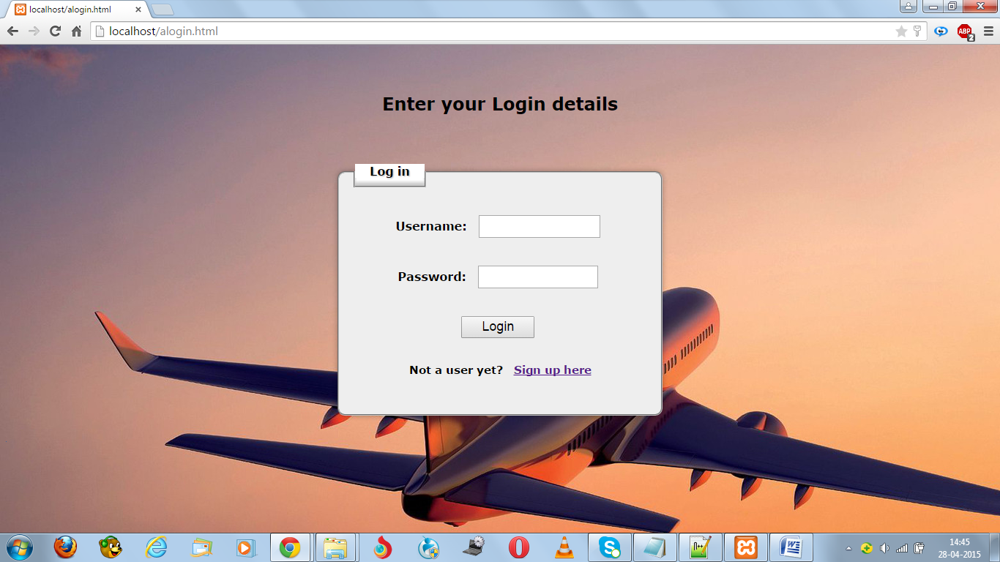

The login page

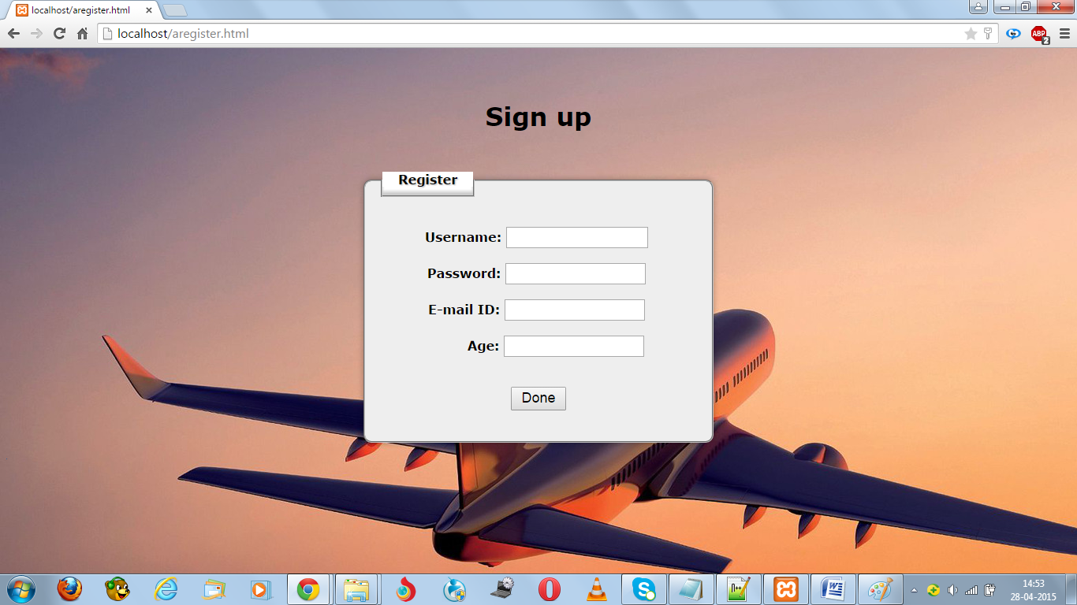

The registration page

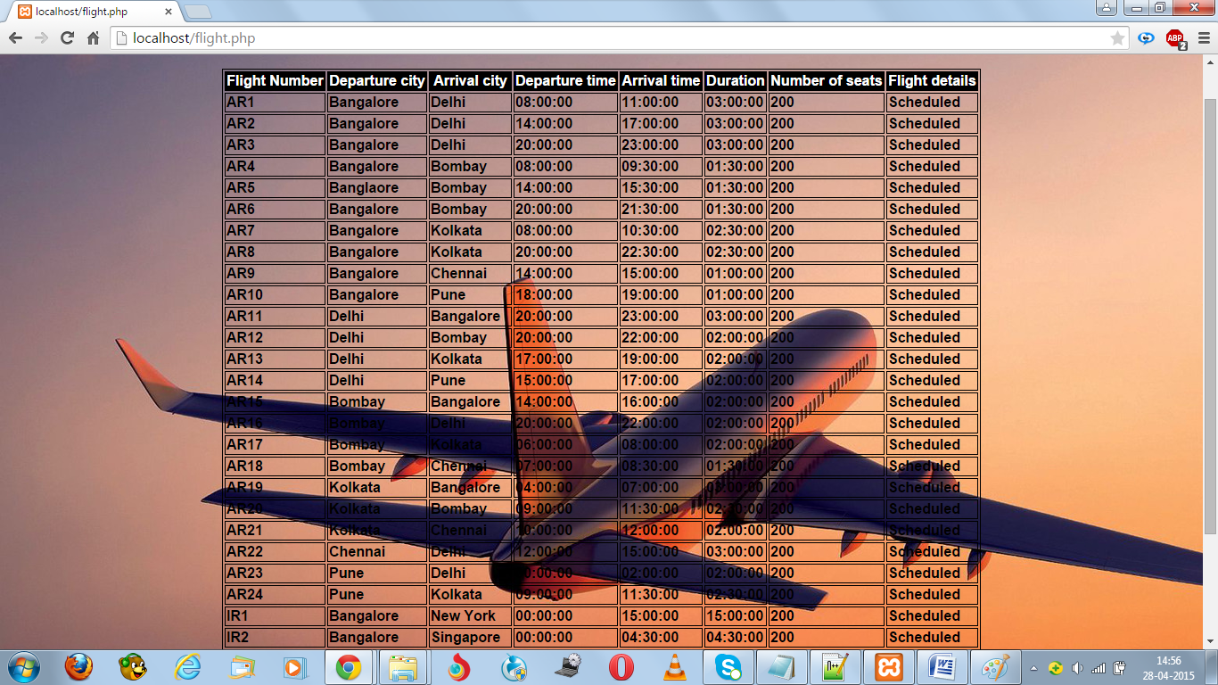

Flight Details

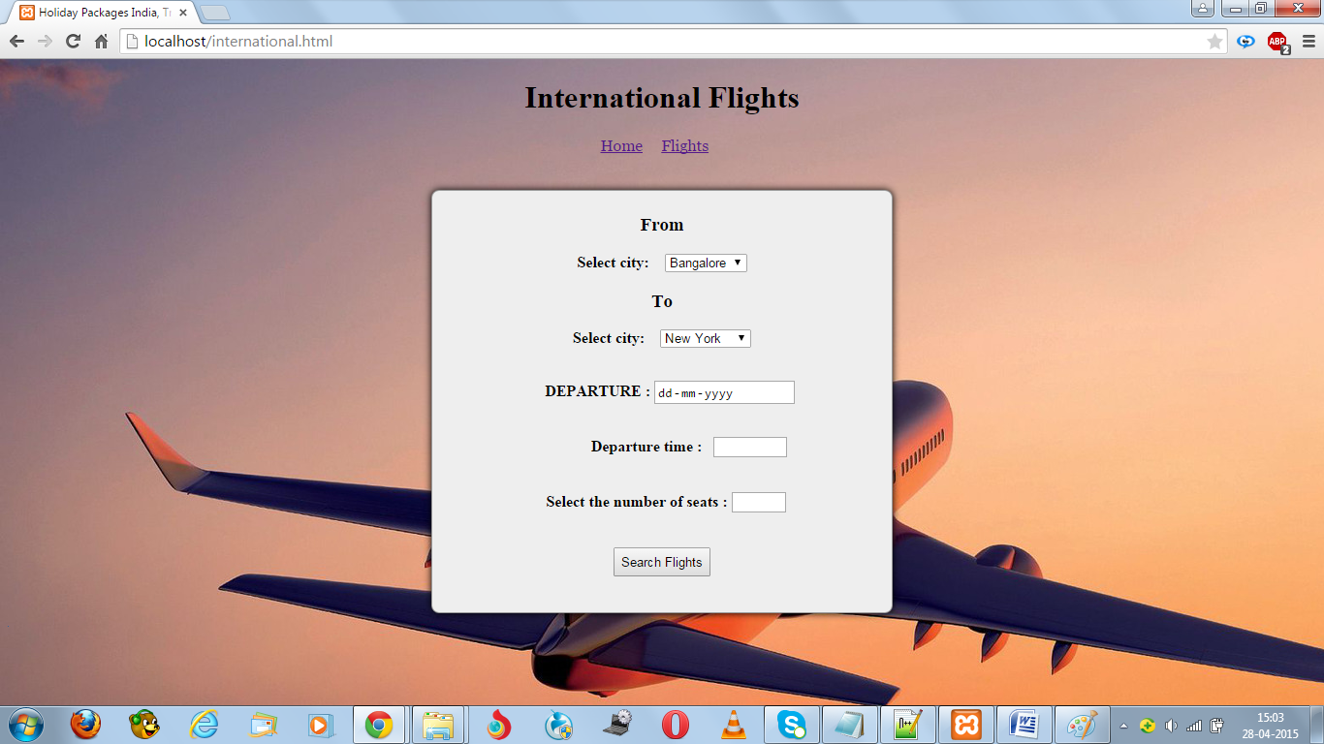

Flight booking form that appears after logging in

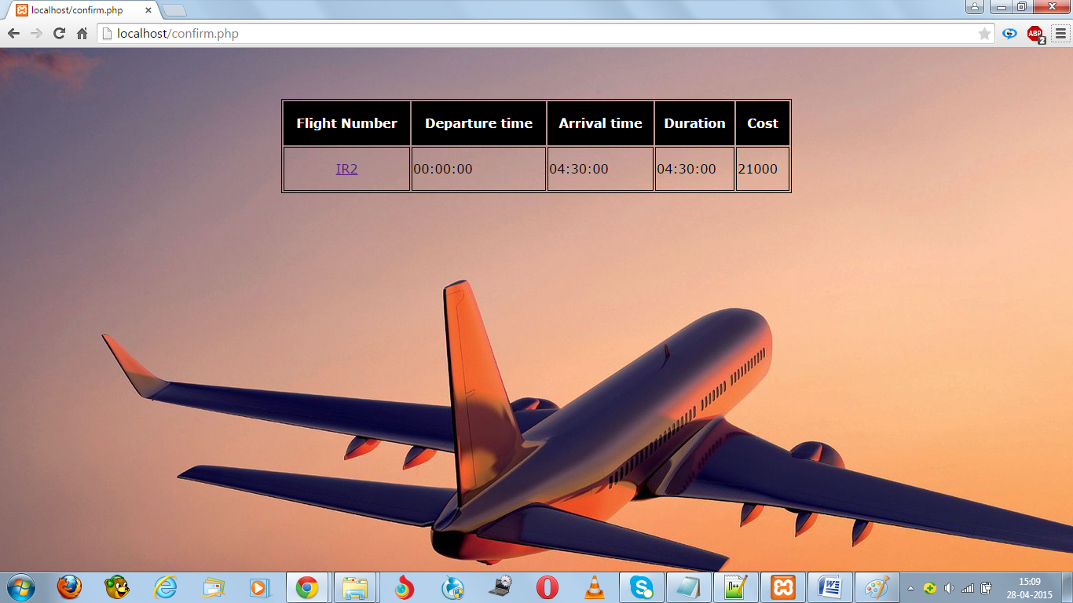

Flight availability for one particular input. Reverts back to previous page if no Flights are scheduled.

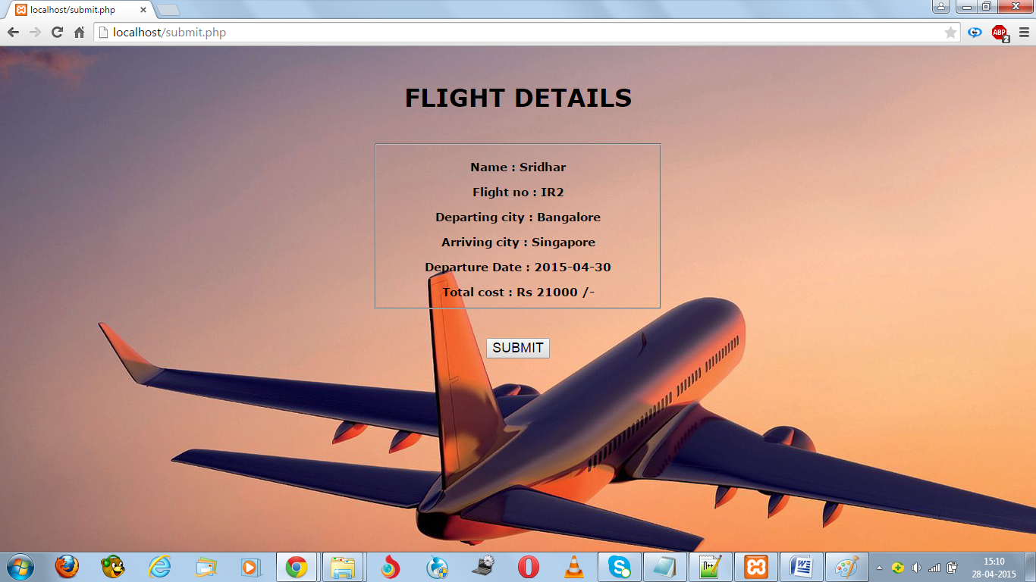

Details of Flight based on input.

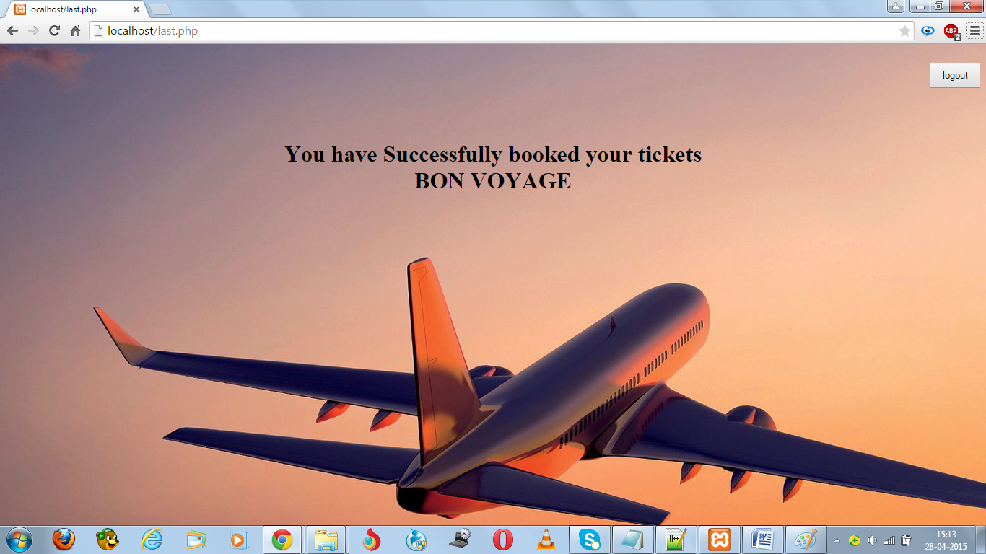

On Submit, confirms the successful booking of ticket.

1. .Testing
2. References

Ms Shubha

Ms Nalina

[www.w3schools.com](http://www.w3schools.com)

[www.stackoverflow.com](http://www.stackoverflow.com)